Hannes Loeschel: Songs of Innocence

Exit Eden featuring Phil Minton; (20903 Col Legno)
12 July 2010

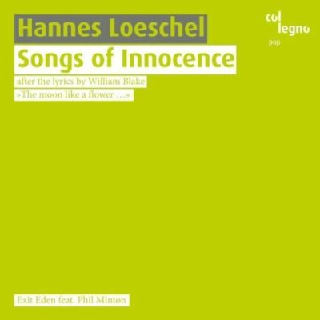

Hannes Loeschel is a Viennese musician whose background in performance of contemporary music has led into a diverse practice divided between improvisation and 'composition in interdisciplinary contexts' (composing and leading ensembles in theatre, dance, and visual art contexts). Here, he sets William Blake's Songs of Innocence cycle, with 'Chapel of Gold' from The Rossetti Manuscript substituting for 'The Little Black Boy', for his ensemble Exit Eden, with guest Phil Minton.
The rich stylistic framework of the 'Introduction' establishes the eclectic tone of the rest of the cycle. Combining the jazzy, ramshackle looseness of Robert Wyatt with a more imperious, darkened Ivor Cutler in the British improvising vocalist Phil Minton, the skittering small band (guitar, piano, bass, drums, trumpet) arrangement is buttressed by chiming melodic figures quietly intimating the major-minor arc of the hypnotic, scene-setting vocal line. The unsettling breath patterns of Thomas Berghammer's trumpet provide a queering element that tells of both the multi-layered aspect of the poems, and of Loeschel's concern to mirror poetic texture with apposite musical expression.
The cycle is packed full of stylistic reminiscence. 'Night' has a Morris bluntness, the staccato spark compelling the ear with an irresistible forward momentum. The harmonic design is centred on much more rote four chord sequences here, but even these are inflected with distant chords and twisting in the lines. Minton bears the weight of affective gatekeeper here, giving off an intricate sense of character. His baritone, here and elsewhere, bears comparison with that of Dead Western, an American musician who operates in similarly obscure, almost-grotesque vocal territory.
What's surprising in the setting, considering the improvisational pedigree of those involved, is how little all of this seems to be improvised - notwithstanding of course the living, organic sense of free detail that defines rock practice (though this music is 'rock' only in the loosest sense). On those tracks with tight vocal arrangements - the slow burning, Fender Rhodes-enhanced gleam of 'Spring', for example - the improvisational element is of course even more constricted.
This constriction matters little to the ear here, truth be told; the sense of grace and relaxed charm—a charm that is responsive always to the text but profoundly creative of its own expressive world all the same—suffuses the record like incoming dusk clouds on a close, enigmatic summer's evening. The tender Rhodes coda to 'A Dream' leads into the dirge-like, Theresa Eipeldauer (who does an admirable job of portraying English folk style)-sung 'The Lamb', for example, in a direct mapping of the dusk that underlies these visionary-pastoral texts.
This sense of grace is leavened by Loeschel's determined sense of the odd. Beefheart, Ribot-esque cronking guitar from Michael Bruckner-Weinhuber in 'On Another's Sorrow' dares the others to follow suit, which they duly do, with tightening darkness in the lyrics producing catatonia from Minton and the others. Minton, always at the heart of the music, is in large part the fount of the oddness; always mischievous, sometimes portending something much darker than that, his total commitment to the material means that Loeschel's fascinating arrangements are given the sheen of both integration and ambiguity. Minton even strays into Billy Bragg territory on the otherwise Black Mountain-recalling stoner rock of 'The Divine Image'; such is the texture of this project's eclecticism.
A confident eclecticism is also evident in the much more spare and fragmented arrangements of 'Infant Joy' (again sung by a charming Eipeldauer), 'Holy Thursday' (which suggests late-period Earth by way of 1970s rock and English sixties pop), and 'The Blossom', which wends its calm way through a two chord vamp on Rhodes, some emotive singing from Minton, and the atmospheric sound of birds chirping. A brutal, distorted 'Chapel of Gold' closes proceedings at a suitable level of overbearing emotional and sonic intensity.
A much-needed sense of integrative purpose canalizes proceedings, as I have said; sparky, generous small-band arrangements that orbit in the space of English folk, jazz, noise rock, experimental pop, and improvised music channel Blake's inspired texts into a fluent musical space of twisting styles and glowing emotions. The sleeve of this fascinating Col Legno release, incidentally, comes complete with charmingly naïve illustrations by Willy Puchner, drawn in response to each poem.
By Stephen Graham

